WEEK 9
DBSE PRACTICAL 9
2520030583

Step 1:
open the zip and Extract the zip
Step 2:
Open Vs.code and select the folder
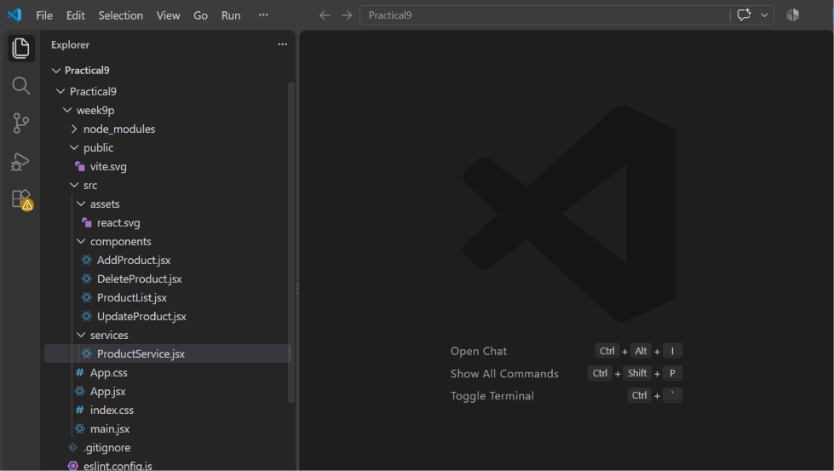
Step 3:
Now open the SpringBoot tools and
create a project
Week 9 (Project structure )
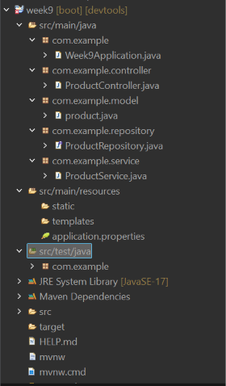

Step 4:

Open src/main/java
there you will find the com.example
In that create packages
com.example
│
├── Week9Application.java
│
├── controller
│ └── ProductController.java
│
├── model
│ └── Product.java
│
├── repository
│ └── ProductRepository.java
│
└── service
└── ProductService.java

Step 5:
In ProductController.java
package com.example.controller;

import java.util.List;

import org.springframework.beans.factory.annotation.Autowired;
import org.springframework.web.bind.annotation.*;

import com.example.model.product;
import com.example.service.ProductService;

@RestController
@RequestMapping("/api/products")
@CrossOrigin(origins = "http://localhost:5173")
public class ProductController {

@Autowired
private ProductService service;

// Get all products
@GetMapping
public List<product> getAllProducts() {
return service.getAllProducts();
}

// Get product by ID
@GetMapping("/{id}")
public product getProductById(@PathVariable Long id) {
return service.getProductById(id);
}

// Add product
@PostMapping
public product addProduct(@RequestBody product p) {
return service.addProduct(p);
}

// Update product
@PutMapping("/{id}")
public product updateProduct(@PathVariable Long id,
@RequestBody product p) {
return service.updateProduct(id, p);
}

// Delete product
@DeleteMapping("/{id}")
public void deleteProduct(@PathVariable Long id) {
service.deleteProduct(id);
}
}

Step 6:
In Product.java

package com.example.model;

import jakarta.persistence.Entity;
import jakarta.persistence.GeneratedValue;
import jakarta.persistence.GenerationType;
import jakarta.persistence.Id;

@Entity
public class product {

@Id
@GeneratedValue(strategy = GenerationType.IDENTITY)
private Long id;

private String name;
private String description;
private double price;
private int quantity;

public product() {
}

public Long getId() {
return id;
}

public void setId(Long id) {
this.id = id;
}

public String getName() {
return name;
}

public void setName(String name) {
this.name = name;
}

public String getDescription() {
return description;
}

public void setDescription(String description) {
this.description = description;
}

public double getPrice() {
return price;
}

public void setPrice(double price) {
this.price = price;
}

public int getQuantity() {
return quantity;
}

public void setQuantity(int quantity) {
this.quantity = quantity;
}
}

Step 7:
In ProductRepository.java

package com.example.repository;

import org.springframework.data.jpa.repository.JpaRepository;

import com.example.model.product;

public interface ProductRepository extends JpaRepository<product, Long> {

}

Step 8:
In ProductService.java

package com.example.service;

import java.util.List;

import org.springframework.beans.factory.annotation.Autowired;
import org.springframework.stereotype.Service;

import com.example.model.product;
import com.example.repository.ProductRepository;

@Service
public class ProductService {

@Autowired
private ProductRepository repository;

public List<product> getAllProducts() {
return repository.findAll();
}

public product getProductById(Long id) {
return repository.findById(id).orElse(null);
}

public product addProduct(product p) {
return repository.save(p);
}

public product updateProduct(Long id, product p) {

product existing = repository.findById(id).orElse(null);

if (existing != null) {
existing.setName(p.getName());
existing.setDescription(p.getDescription());
existing.setPrice(p.getPrice());
existing.setQuantity(p.getQuantity());

return repository.save(existing);
}

return null;
}

public void deleteProduct(Long id) {
repository.deleteById(id);
}
}

Step 9:
In application.properties
spring.application.name=week9

server.port=8085

spring.datasource.url=jdbc:mysql://localhost:3306/productdb
spring.datasource.username=root
spring.datasource.password=root

spring.jpa.hibernate.ddl-auto=update
spring.jpa.show-sql=true
spring.jpa.properties.hibernate.format_sql=true

Step 10:
Now run it as Spring boot app

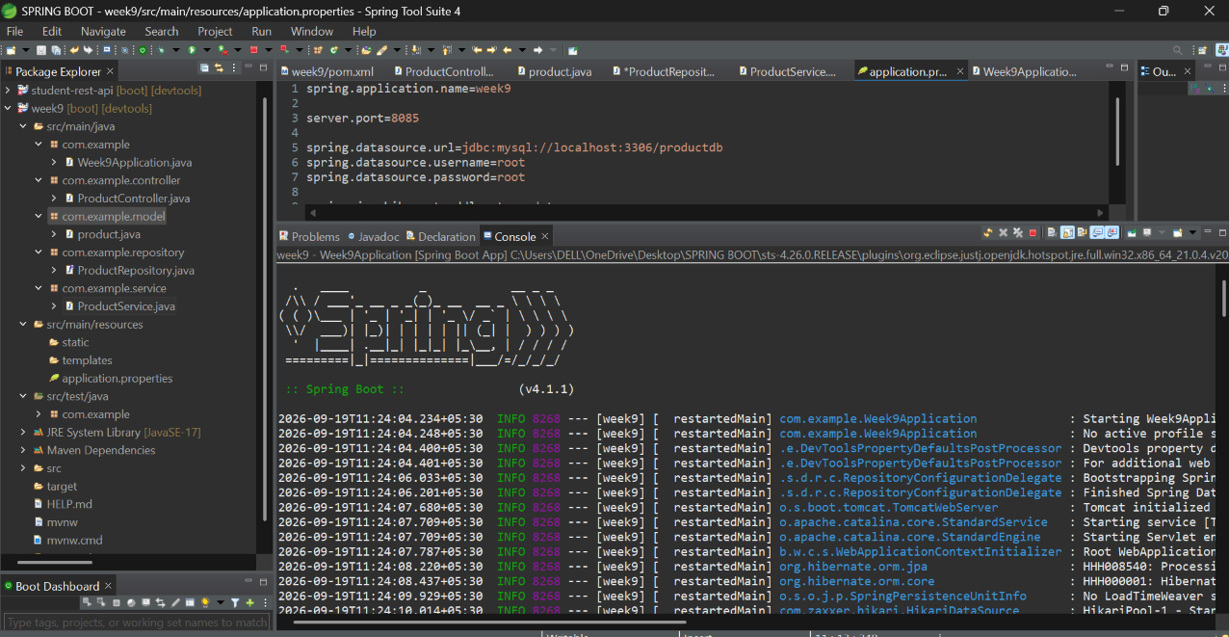
Step 11:
Now open the mysql
incmd and create the database
called Create database Productdb;

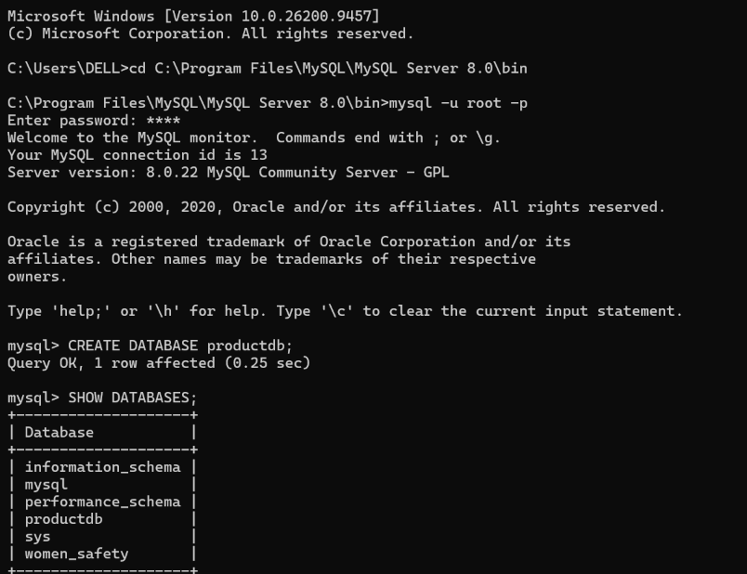

Step 12:
Use productdb;
And
Show tables;
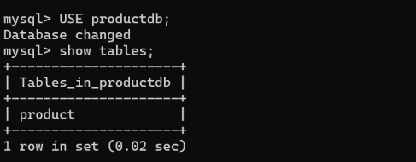

Step 13:
Open Postman
Post http://localhost:8085/api/products

And Get the data

and enter the Data
[
{
"description": "HP Pavilion Laptop",
"id": 2,
"name": "HP Laptop",
"price": 60000.0,
"quantity": 10
},
{
"description": "HP Pavilion Laptop",
"id": 3,
"name": "HP Laptop",
"price": 60000.0,
"quantity": 10
},
{
"description": "Wireless Bluetooth Headphones",
"id": 4,
"name": "Headphones",
"price": 3000.0,
"quantity": 15
},
{
"description": "Mechanical Gaming Keyboard",
"id": 5,
"name": "Keyboard",
"price": 4500.0,
"quantity": 8
}
]

Step 14:
Check the entered Data in mysql
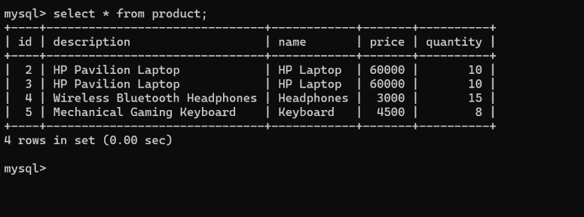

Step 15:
Now open the Vs code
and run the week 9
npm install (to install packages)
npm run dev (to run the program)
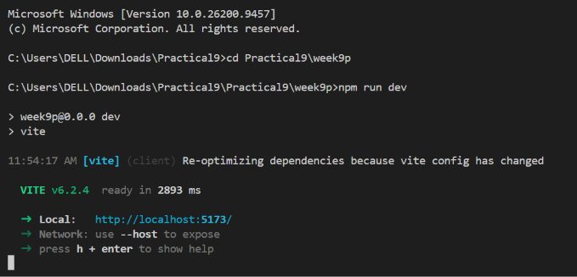

Step 16:
Open the local host
http://localhost:5173/

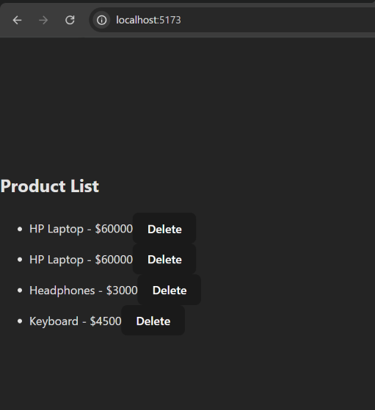

Now this is the final output

